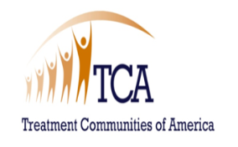 | The  RICHARD PRUSS  Professional Development Scholarship

Individual Professional Development Plan

Dear Applicant:
In an essay of no more than 500 words, please address the following criteria:
- GOALS: What are your goals, and how do they relate to effective prevention, treatment or recovery and the mission of the organization that you currently work with or the field of study which you are enrolled?

- OBJECTIVES: What specific development objectives (particularly the ones that this scholarship will support) do you expect to accomplish within the next year?

- DEMONSTRATE NEED: What support system and alternate methods of funding are available to assist you with implementing your professional plan?
This will assist the Scholarship Award Committee to understand your needs and motivation related to your professional growth and development as an addiction professional.
Sincerely,
The Richard Pruss Professional Development Scholarship Committee

